# Phase 1 Practice Project – Assisted Practice

**2 . Write a program in java implementing the Binary search algorithm**

**package** algorithms;

**public** **class** BinarySearch {

**public** **static** **int** binarySearch(**int**[] arr, **int** target) {

**int** left = 0;

**int** right = arr.length - 1;

**while** (left <= right) {

**int** mid = left + (right - left) / 2;

**if** (arr[mid] == target) {

**return** mid; // Element found, return its index

}

**if** (arr[mid] < target) {

left = mid + 1;

} **else** {

right = mid - 1;

}

}

**return** -1; // Element not found in the array

}

**public** **static** **void** main(String[] args) {

**int**[] arr = {5, 18, 25, 31, 23, 80, 70};

**int** target = 31;

**int** index = *binarySearch*(arr, target);

**if** (index != -1) {

System.***out***.println("Element " + target + " found at index " + index);

} **else** {

System.***out***.println("Element " + target + " not found in the array.");

}

}

}

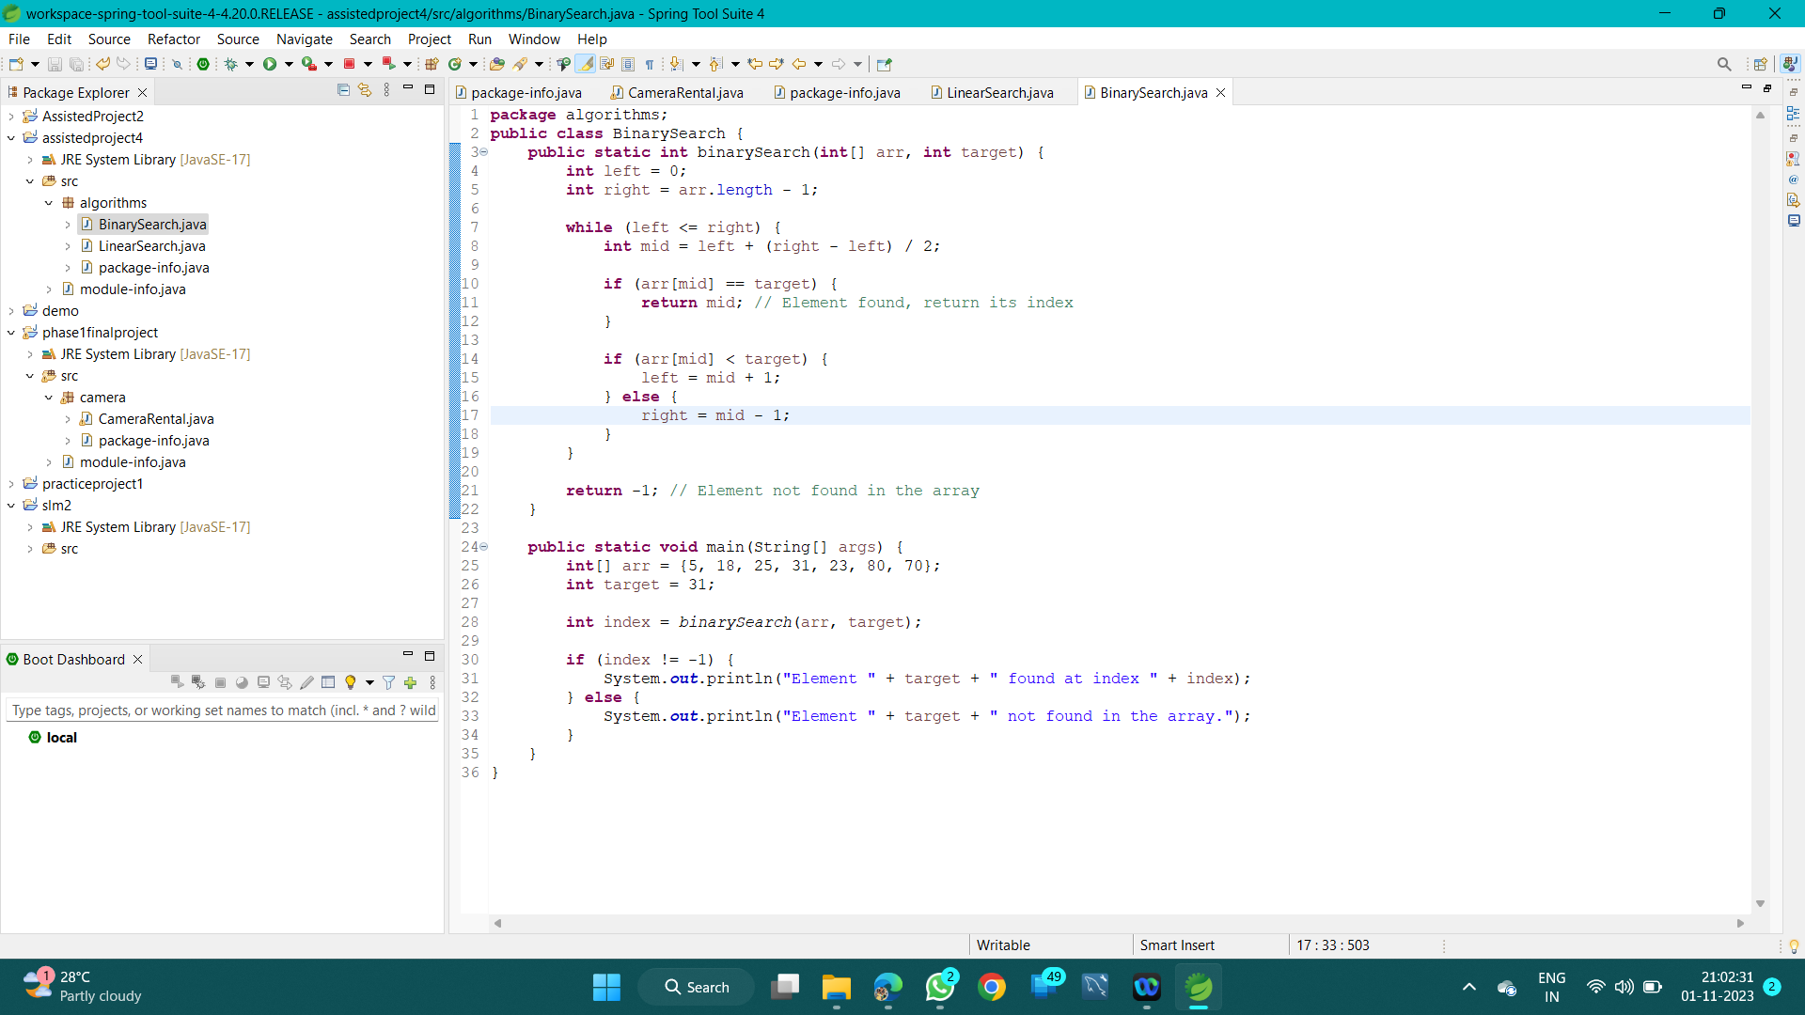

# OUTPUT:

# 